Appendix A

Productivity Dashboard
The Texas State University System does more with less - with better result - than any other university system in Texas. With a 71 percent increase in degree production over the last decade, TSUS institutions are responding to the demands of our growing state and producing graduates who contribute to Texas' economic vitality and quality of life. The Texas State University System's state appropriation per degree is 28 percent lower than the state average, and our tuition and fees are among the lowest in the state. Our Productivity Dashboard provides data on these and other important performance measures.
 | Employed Or In Graduate School  More than 80% of TSUS graduates are employed and/or enrolled in graduate school in Texas within a year after graduating, exceeding the state average every year for the past decade. | 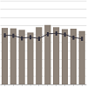

 | Degrees Awarded  Over the past decade, the number of degrees earned at TSUS institutions increased 71%. | 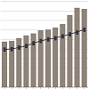

 | Faculty Teaching  TSUS faculty teach 21% more semester credit hours than the state average. | 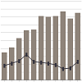

 | Faculty growth  Over the past decade, enrollment growth at TSUS institutions has outpaced faculty growth by 14%. | 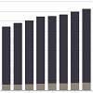

 | Student-To-Faculty Ratio  TSUS's student-to-faculty ratio is 19% higher than the state average. | 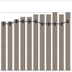

 | ENROLLMENT Growth  TSUS enrollment has increased 44% over the past decade, exceeding the state's growth in enrollment. | 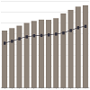

 | Tuition and Fees  In 2011, TSUS tuition and fees per full-time student equivalent were 15% below the state average. | 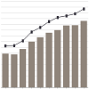

 | State Appropriation Per Degree  In 2011, the state appropriation per degree for TSUS was 28% below the Texas public university average. | 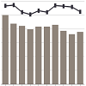

 | State Appropriation Per FULL-TIME STUDENT EQUIVALENT  Last year, TSUS's state appropriation per full-time student equivalent was 25% lower than the state average. | 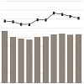

 | Six-Year Graduation Rate  TSUS's six-year graduation rate has increased 37% over the past decade, exceeding the state increase by 12%. | 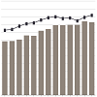

 | Degrees awarded Per 1,000 students  TSUS degree production per full-time student equivalent has increased 24% over the last 10 years. | 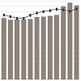

Source: Texas Higher Education Coordinating Board

- About
- Leadership
- Institutions
- Dashboard
- Newsroom
- Contact Us
- Students & Parents
- Faculty & Staff
- Alumni & Friends
- Privacy & Security Policy
- Accessibility
- Governor's Committee on People with Disabilities
- Open Records Policy
- Compliance & Ethics Line
- HUB Program
- Texasonline
- Statewide Search
- Compact with Texans
- Window on State Government
- State Auditor's Fraud Reporting Hotline
- Texas Veterans Portal
The Texas State University System
Thomas J. Rusk Building • 208 E. 10th Street, Suite 600 • Austin, Texas 78701-2407
Phone: (512) 463-1808 • Fax: (512) 463-1816
©2013 The Texas State University System All Rights Reserved.

Appendix B
